**Chapter 3:**

**Fundamentals of WAN**

* **Leased Lines:**

The term *Leased Line* refers to the fact that the company using the leased line does not own the line, but instead pays a monthly fee to use it. Service Provider is the common word for these kinds of companies.

Some important terminologies are:



* **Leased-Line Cabling:**

The telco (service providers) installs cables from the Central Office to most every other building in the city, expecting to sell services to the people in those buildings one day. The telco would then configure its switches to use some of the capacity on each cable to send data in both directions, creating the equivalent of a crossover cable between the two routers.

**CPE:**

Each site has customer premises equipment (CPE), which includes the router, serial interface card, and CSU/DSU. Each router uses a serial interface card that acts somewhat like an Ethernet NIC, sending and receiving data over the physical link.

**CSU/DSU:**

The physical link used by router to transmit data requires a function called a *Channel Service Unit/Data Service Unit* (CSU/DSU). The CSU/DSU can either be integrated into the serial interface card in the router or sit outside the router as an external device.

It is important to know that companies provide service for sending bits only (i.e. physical layer) over leased lines. So, we use protocols to make possible transmission of bits over a physical link of particular type.

**HDLC (High-Level Data Link Protocol):**

This protocol ensures the safe transmission of data by maintaining a point-to-point topology. An HDLC frame is sent from a router and the frame itself contain the destination address so the exit point here is implied. HDLC frame has several same fields as Ethernet frame. See the table below:



Important: *Ethernet frame is used in LANs and HDLC frame is used in WANs. But today Ethernet is being used as WAN Technology as well.*

**Ethernet as WAN:**

Ethernet can be used as WAN technology as well by deploying fiber Ethernet links between customer and Service Providers and vice versa (to complete the connection).

**EoMPLS (Ethernet over Multi-Protocol Label Switching):**

EoMPLS (Ethernet Emulation) is a technology used in the SP’s cloud that make the Ethernet connection as a single Ethernet link. This service provides:

1. A Point to Point connection between two customer devices
2. Behavior as if a fiber Ethernet Link exists between the two devices

A pictorial illustration is given:



As in HDLC protocol, we know that it sends data over the leased line and it do so by using HDLC frames. But Ethernet emulation uses simple Ethernet frames at each site and within the WAN technology as well. See the difference below (at circle 2):

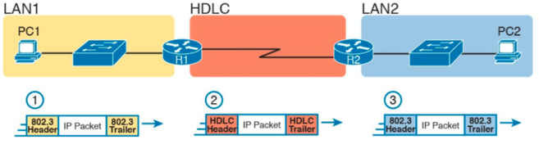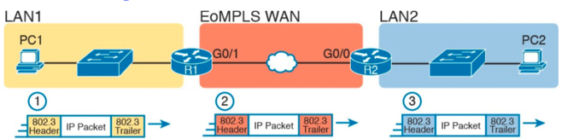

**Digital Subscriber Line (DSL):**

DSL is a pretty common house-hold level very fast internet that uses already installed Telephone lines in the homes. It doesn’t replace leased lines instead it is a short distance internet link from telco office to home (on the other hand, leased lines can have distance of many-a-miles). DSL modem connects to a spare telephone outlet. See the figure:



The concept is pretty simple here as DSL model is using a spare telephone line. DSLAM is a multiplexer used at telco CO, which sends voice data from/to Voice Switch and sends internet packets to rest of the internet using a router. Moreover, DSL supports asymmetric speeds, which means the downstream (transmission speed from ISP towards the home) is pretty faster than the upstream (to the ISP). It is because, few hundreds of bytes are sent if we click on a webpage but it may trigger many Megabytes of data to be delivered to home.

**Cable Internet:**

Cable internet works in the same way as DSL. Like DSL, it too uses existing cable (Co-axial cable), supports Asymmetric speeds, and doesn’t try to replace leased lines. The cable internet works in the same way as DSL, see the figure:



Cable Co. splits the video and data and sends it to relevant end. Data flows through the router to the internet and video comes in from Dishes into the homes.